BRAINWARE UNIVERSITY
PYTHON PROJECT-BASED LEARNING REPORT (WEEK 1)

1. Basic Information
Title of the Project: | Student Grade Management System (Terminal-Based)
Name(s) of Student(s): | Soumyadwip Das (BWU/BTS/25/169)  Ankita Paul (BWU/BTS/25/180)  Sonia Naskar (BWU/BTS/25/195)  Joyeta Mondal (BWU/BTS/25/214)  Sayantan Bharati (BWU/BTS/25/503)
Programme & Semester: | B.Tech CSE & 3rd Semester
Course Name & Code: | Python Programming Lab (BES09013)
Name of the Guide/Supervisor: | MR. PRANAB GHARAI & MR. INDRANIL DAS

2. Introduction and Background
Student grade management is an important academic task involving the recording, calculation, and retrieval of student performance. This project develops a console-based application that manages student records in memory using Python. Week 1 focuses on implementing the core features, including grade calculation, a menu-driven interface, and operations to add, view, search, update, and delete student records.
3. Objectives of the Project (Week 1)
- Develop a menu-driven application for managing student records.
- Implement Add, View, Search, Update, and Delete operations.
- Calculate grades from percentage scores.
- Build a reusable bordered terminal interface.
- Validate roll numbers and marks.
- Test all CRUD operations.
4. Problem Statement / Driving Question
How can student records, including marks, percentages, and grades, be efficiently managed using a simple terminal-based application?
5. Methodology (Week 1 Activities)
1. Data Model & Storage:
- Used an in-memory STUDENTS dictionary to store student records and a fixed SUBJECTS list for consistent data handling.
2. Grade Calculation Logic:
- Implemented calculate_grade() to assign letter grades and get_report() to calculate total marks, percentage, and grades
3. Terminal UI & Menu System:
- Developed reusable box-drawing functions for the interface, implemented a menu with Add, View, Search, Update, Delete, and Exit options, and added input validation for roll numbers and marks.
6. Expected Outcomes / Deliverables (Week 1)
- A working console application supporting Add, View, Search, Update, and Delete of student grade records
- A functioning calculate_grade() module producing consistent letter grades from percentage scores
- A bordered, readable terminal UI built from reusable box-drawing utilities
- Input validation for duplicate roll numbers, invalid marks, and non-numeric entries
- Week 1 project report

7. Core Logic
def calculate_grade(percentage):
if percentage >= 90:
return "A+"
elif percentage >= 80:
return "A"
elif percentage >= 70:
return "B+"
elif percentage >= 60:
return "B"
elif percentage >= 50:
return "C"
elif percentage >= 40:
return "D"
else:
return "F"

def get_report(roll):
student = STUDENTS[roll]
total = sum(student["marks"].values())
max_total = 100 * len(SUBJECTS)
percentage = (total / max_total) * 100
grade = calculate_grade(percentage)
return student, total, percentage, grade
calculate_grade() assigns a grade based on the percentage, while get_report() calculates the total, percentage, and final grade. Together, they provide the core logic for generating student reports across the application.

8. Output Screenshot
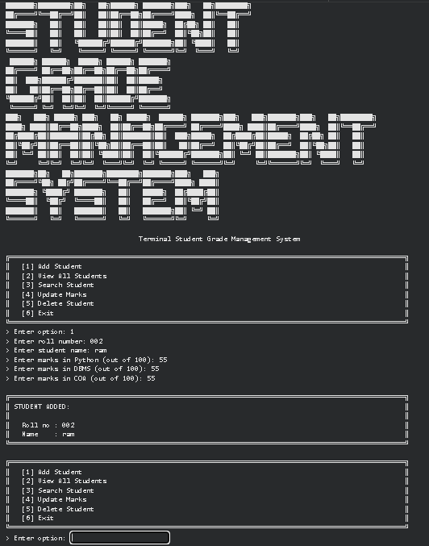

9. Project Timeline
9. Tools & Technologies Used
Tool / Technology | Purpose
Python 3.x | Core programming language
Python Dictionary (dict) | Store student records in memory
Python Standard I/O | Handle menu-driven user interaction
Exception Handling | Validate input and handle errors
Box-Drawing Characters | Create the bordered terminal interface

10. References
- Python Official Documentation
- Python Dictionaries Documentation
- Python Errors and Exceptions Documentation
- Unicode Box Drawing Characters Reference
- Brainware University – Python Programming Course Guidelines

11. Signatures
Signature of Student(s): Date of Submission:

Signature of Guide/Supervisor:

